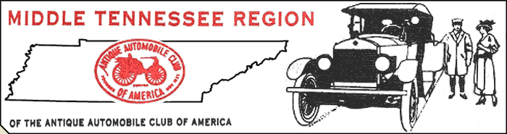
Glenn Edwards, President ~ Dr. Roger McKinney, Vice-President ~ Read Majors, Secretary ~ Marc Humes, Treasurer

April 2010

Spring has sprung! Soon we will be up to our necks in cars shows, cruise-ins and all the other cool stuff we have waited for all winter. Be sure and keep up with the club schedule so you won't miss anything. The AACA magazine you receive each month is good for tracking national events and I will do my best to keep you posted on our own club happenings.

A “Call Tree” is in the planning stage so those of you who don't use e-mail can be contacted quickly if the need arises. We want to thank Linda O'Guin for taking on the job of setting this up. More on this later.

Jack Daniels Tour – This event is Saturday June 5th and the trip to Lynchburg is a lot of fun! The cost is $15.00 per person and money should be sent to Ann Jones by May 15th. Ann's address is 156 Sunset Dr. Mt. Juliet 37122. You may also send the money to Treasurer Humes ( 600 Peyton Rd. Lebanon 37087) and he will forward it to Ann. If you send it to Marc, do it early so all deadlines can be met.

  - “Dumplin Days” at Fiddler's Grove is April 17th. Members cars will be displayed throughout the Grove and should be on site at 8 AM. Lots of entertainment in store so bring all your friends and family.
  - Pot Luck Supper at the clubhouse Friday March 26th at 6:30. Bring soup, salad, sandwiches, desserts, etc. Be sure and invite family and friends, all are welcome. If you have never come to one of our Pot-Lucks, you have missed good food and good fellowship! This is where we get together and just have fun ( and EAT!!!!).
  - If you have any ideas for a Club Tour contact Activities Chair Valerie Edwards with your suggestions.
  - Next regular meeting Sunday April 11th at 2PM. Be there.

Seeya' soon – be safe!

MTRAACA EVENTS 2010

April 17th – Dumplin' Days at the Fairgrounds
May 2nd – Mt. Juliet Car Show at WB&T
May 29th – Granville Heritage Days
June 27th – Murfreesboro Summerfest at WB&T ( Hwy 231 Murf.)
August 15th – Wilson County Fair
Sept. 10 and 11th – Red Boiling Springs
Sept. 18th – Gladefest
October 17th – Oktoberfest at WB&T (main office)

